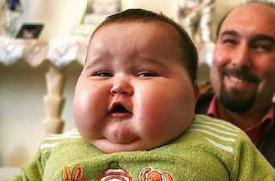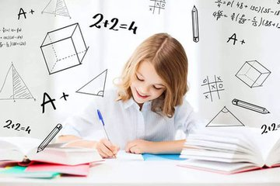First, we must have breakfast every morning. It’s good for our body . And make our body grow strong and strong…… But you must eat good food for your breakfast. Such as egg, vegetable, fruit, bread or some milk.
Third . Have good living habits. It’s good for we.Brush your teeth, eat good food ,wash your face. It’s good habits.
Now ,lets be a strong and healthy children .

First, ,we must have breakfast every morning. It’s good for our body . And make our body grow strong and strong…… But you must eat good food for your breakfast. Such as egg, vegetable, fruit, bread or some milk.
Second do exercise everyday. Such as swimming, running, walking , playing pingpong, playing basketball, playing volleyball,and football.it’s a very good news.

Good health to you
Strong and healthy is very important for us. But how can we be strong and healthy ? It’s really easy!

